1.BUILD MVC FORM AS GIVEN BELOW USING ANNOTAIONS LIKE @REQUESTMAPING,@MODEL ATTRIBUTE ETC..

OUTPUT:

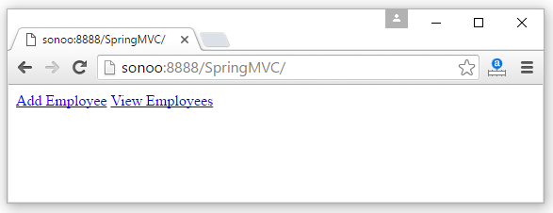

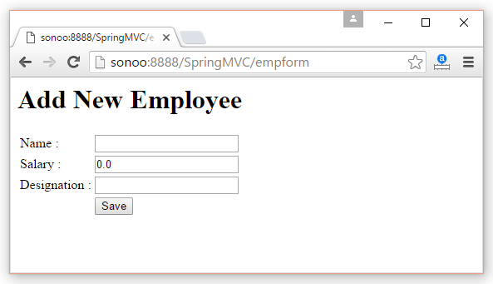

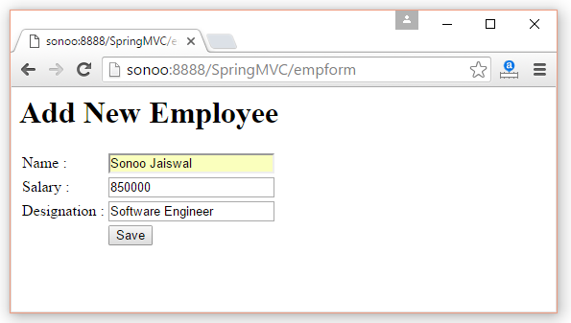

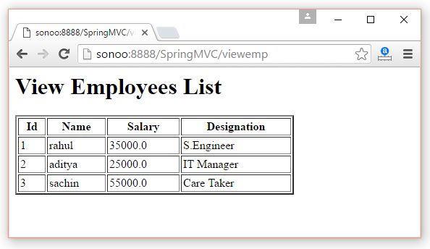

2. USING SPRING MVC , BUILD FORM UI VALIDATIONS USING ANNOTATIONS FOR THE BELOW REQUIREMENTS.

BUILD USER APPLICATION WITH BELOW FIELDS INFO

FIRST NAME-->First name cannot be null and must have size greater than 0

LAST NAME-->Second name must not be null, empty value/space can be considered

USER NAME-->Username must not be null and must contain 1 or more characters

AGE -->Age must be greater than 18 , Age must be smaller than 25

ABOUT ME-->About Me must be between 10 and 200 characters

EMAIL-->Email should be valid

PASSWORD--->APPLY REG EXPRESSIOM

ISWORKING-->APPLY ASSERT ANNOTATIONS

ISSTUDENT--> APPLY ASSERT ANNOTATIONS

3.FOR CUSTOMER SALES INFORMATION BUILD FORM UI VALIDATIONS.

CUSTFNAME --CHECK FOR EXISTANEC OF VALUE AND MAKE SURE REQUIRED IF NOT

CUSTLNAME-- CHECK FOR EXISTANCE OF MINIMUM 10 CHARS IN THE NAME

ADDRESSCODE--APPLY REG EXP FOR CHECKING MUST CONTAIN ALL CHARACTERS,NUMERICS,ONE SPECIAL CHAR -

LOCATION -- MUST NOT CONTAIN SPECIAL CHARS

SALESQTY-- SALES QUANTITY IS MUST BE ABOVE 200 AND LESS THAN 20000

TOTAL AMOUNT--SHALL BE LEAST 2000000

TARGETACHIVED---CHECK FOR TOTAL AMOUNT REACHED THE TARGET OR NOT WITH ASSERTIONS.